**Hands on Exercise**

You will style a form with CSS in this Hands-On Practice. To get started, launch a text editor and open the starter.html file from the chapter10 folder in the student files. Save the file with the name contact.html. When you have completed, your form will be similar to the example in ­[**Figure 10.17**](https://jigsaw.vitalsource.com/books/9780133971026/epub/OPS/xhtml/fileP700049506200000000000000000337C.xhtml#P70004950620000000000000000033BD).

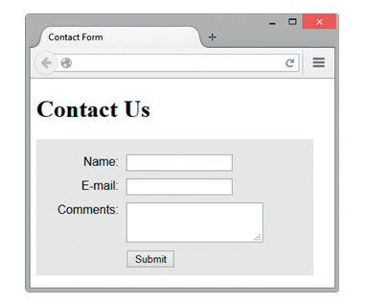

**Figure 10.17 *The form is styled with CSS.***

The HTML for the form is shown below for your reference:

<form>

 <label for="myName">Name:</label>

 <input type="text" name="myName" id="myName">

 <label for="myEmail">E-mail:</label>

 <input type="text" name="myEmail" id="myEmail">

 <label for="myComments">Comments:</label>

 <textarea name="myComments" id="myComments"

rows="2" cols="2 0"></textarea>

 <input type="submit" value="Submit">

</form>

Configure embedded CSS as follows:

1. **The form element selector.** Configure form elements with a #EAEAEA background color, Arial or sans serif font, 350px width, and 10 pixels of padding:

form { background-color: #EAEAEA;

font-family: Arial, sans-serif;

width: 350px; padding: 10px; }

1. **The label element selector.** Configure label elements to float to the left, clear left floats, and use block display. Also set width to 100px, 10 pixels of right padding, a 10px top margin, and right-aligned text:
2. label { float: left; clear: left; display: block;
3. width: 100px; padding-right: 10px;

margin-top: 10px; text-align: right; }

1. **The input element selector.** Configure input elements with block display and a 10px top margin:

input { display: block; margin-top: 10px; }

1. **The textarea element selector.** Configure textarea elements with block display and a 10px top margin:

textarea { display: block; margin-top: 10px; }

1. **The submit button.** The submit button needs to display under the other form controls, with a 110 pixel margin on the left. You could configure a new id or class and then edit the HTML, but there is a more efficient method. You will configure a new type of selector, an **attribute selector,** which allows you to select using both the element name and attribute value as the criteria. In this case we need to style input tags that have a type attribute with the value submitin a different manner than the other input tags, so we’ll configure an attribute selector for this purpose. The CSS follows:

input[type="submit"] { margin-left: 110px; }

Save your file and test your page in a browser. It should look similar to [**Figure 10.17**](https://jigsaw.vitalsource.com/books/9780133971026/epub/OPS/xhtml/fileP700049506200000000000000000337C.xhtml#P70004950620000000000000000033BD).